How to Change Your Address Online
⚠️ Note:
If you do not yet have an account, you will need to create one. A guide titled “How to Create a New Account” is the first “How To” listed on the Help page.
⚠️ IMPORTANT: Licensees have the option of entering a business address into the online licensing system that will be publicly available and displayed, without redaction, in search results returned from the online licensing system. This will ensure those licensees using their home address as the main address for agency correspondence have the option of displaying a publicly available address where members of the public may contact them.
The decision of whether to utilize a home address as the main address, as well as the decision of whether to enter a business address in the online licensing system is left to each individual licensee. While licensees are not required to enter a business address into the online licensing system, they are encouraged to do so as a point of convenience for the public.
Licensees wishing to display a business address can do so by logging into the online licensing system and executing a change of address in the system. Simply go to the “Add Another Contact” section and select the business address to enter that address. Both addresses will then be displayed on the public search feature found on our website, but the main address will only display city, state, county and zip code.
It should be noted that the address entered as a main address, including a home address, will be publicly available under the Public Information Act unless the licensee indicates the address is his or her home address in the online licensing system.

Step 1: Log Into Your Account
Go to the online licensing system:
🔗 Online Licensing System
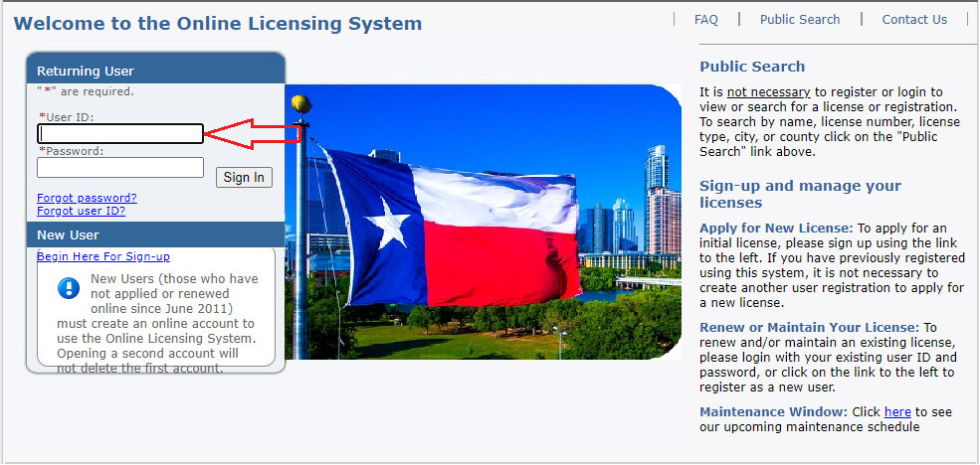

Step 2: Start the Address Change Process
- From the “Manage your license information” section, select:
Mailing Address Change
- Click Select
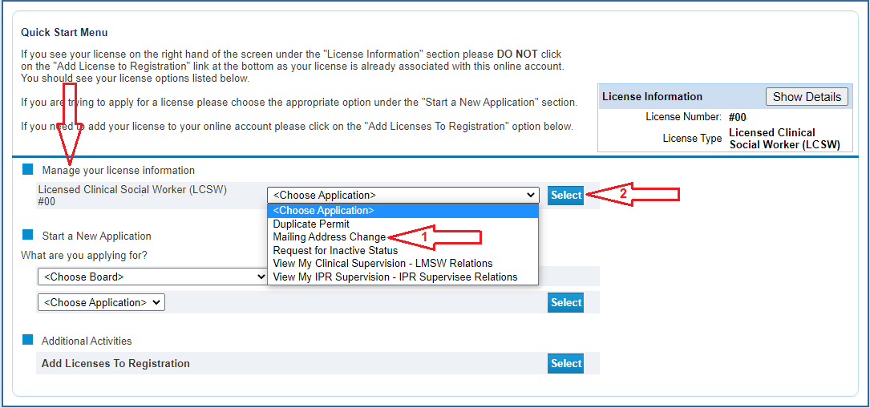

Step 3: Read and Continue
Review the introductory information and click Next to proceed.
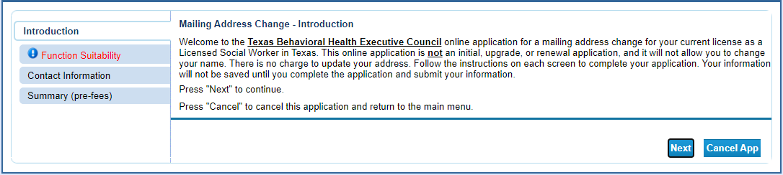

Step 4: Complete the Function Questions
Answer the brief system questions to confirm you're using the correct tool. Click Next.
⚠️ If your answers do not match the requirements, you’ll receive an error message directing you to a different tool.
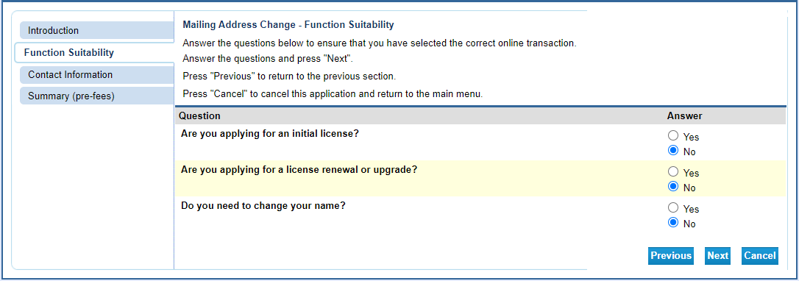

Step 5: Enter Your Updated Address
- Input your new address information
- Format your phone number manually, as the system does not auto-format
- Click Next
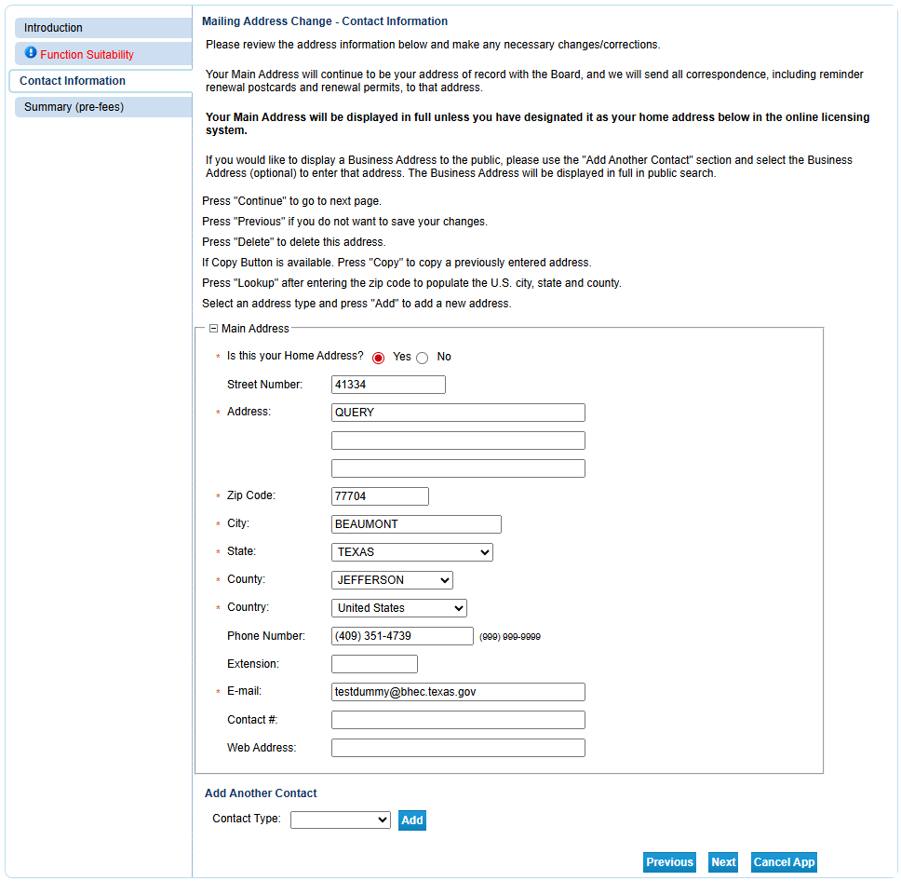

Step 6: Review and Submit
Check all the information for accuracy. When ready, click Submit.
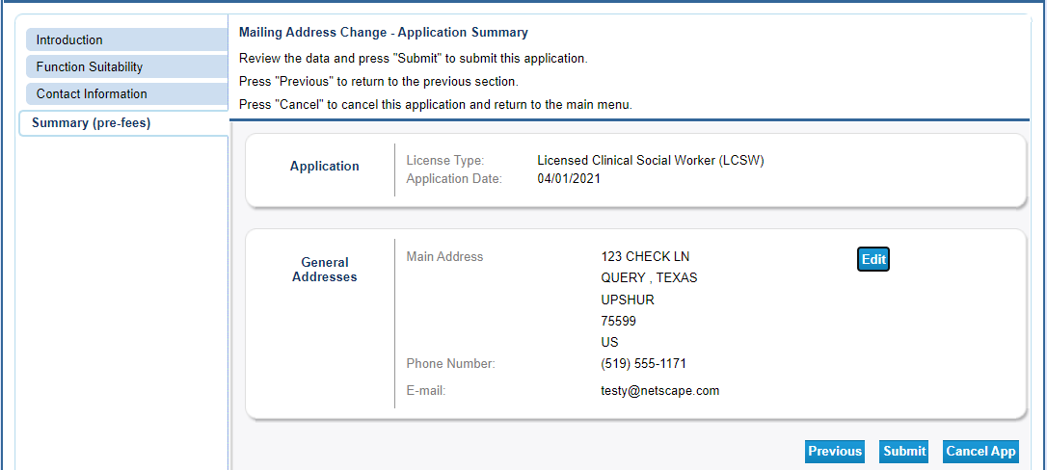

Step 7: Complete the Attestation
- Select Yes to agree to the attestation
- Click Next
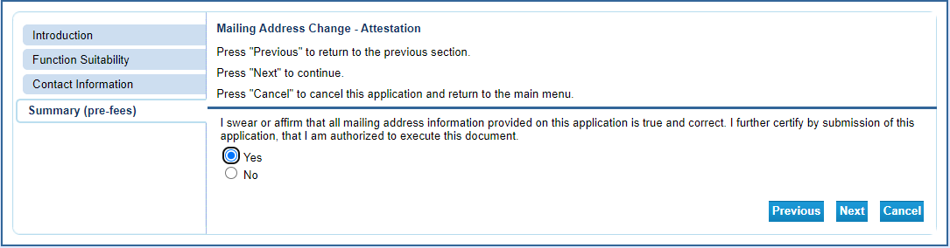

Step 8: Confirmation
- You will see the Fee and Summary Report screen; there is no fee to update your address
- The change becomes effective immediately
- You will receive a confirmation email with a summary of your changes attached
Click Return to go back to the Quick Start menu.
