How To Request Issuance of Psychologist License

IMPORTANT: Before you initiate the online application process, be sure you have the required supplemental documentation saved to your device. You will be prompted to upload this documentation toward the end of the process. The list of required documentation can be found here.

Step 1 – Log In or Create an Account
- Go to the [Online Licensing System] and log in.
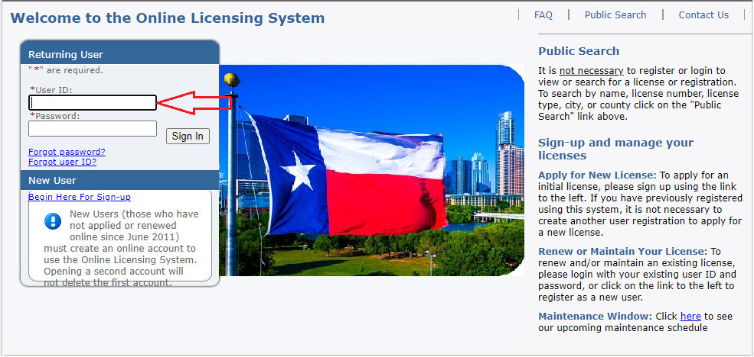
- If you do not have an account, you will need to create one. A guide on how to create a new account is available at the top of the webpage.
Step 2 – Select License Type
- From the first drop-down, choose Texas Behavioral Health Executive Council.
- Then select Licensed Psychological Associate Online Initial and click Select.
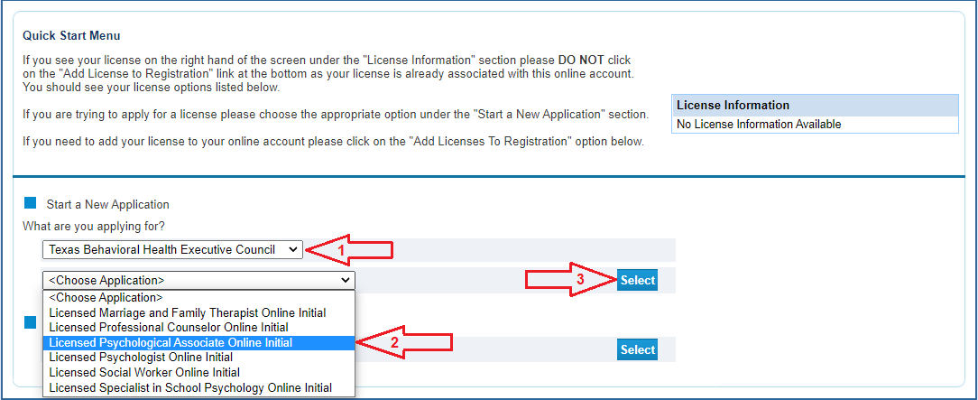

Step 3 – Begin the Application
- Read the introduction and click Next.
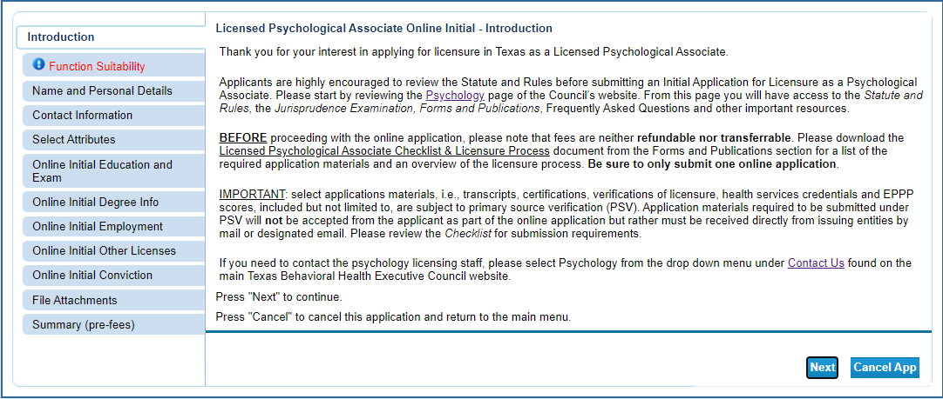
Step 4 – Function Questions
- Answer the function questions to verify you are completing the correct application.
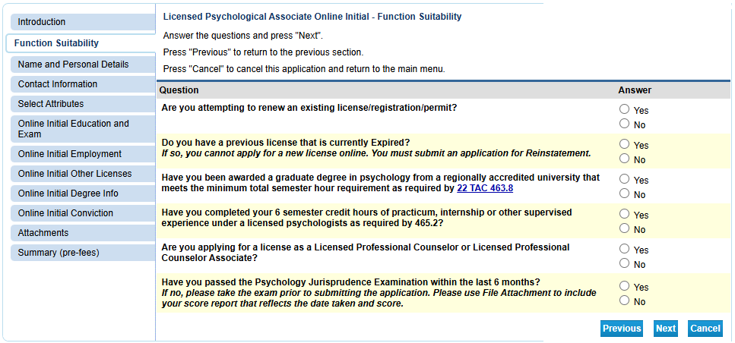
- If your answers indicate another license type, you will receive an error message.

Step 5 – Personal Details
- Enter or update your personal information, then click Next.
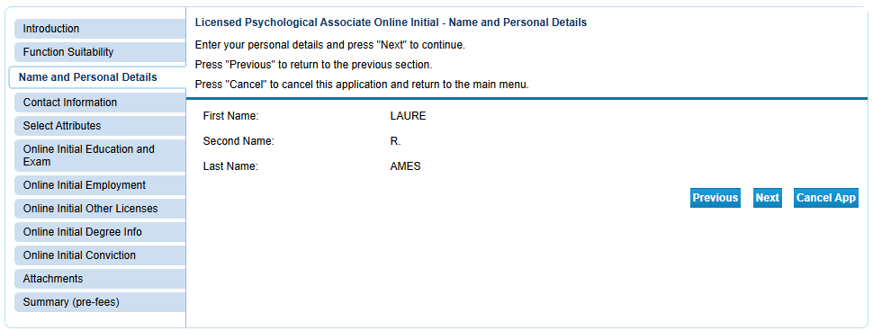

Step 6 – Contact Information
- Enter your contact details and click Next.
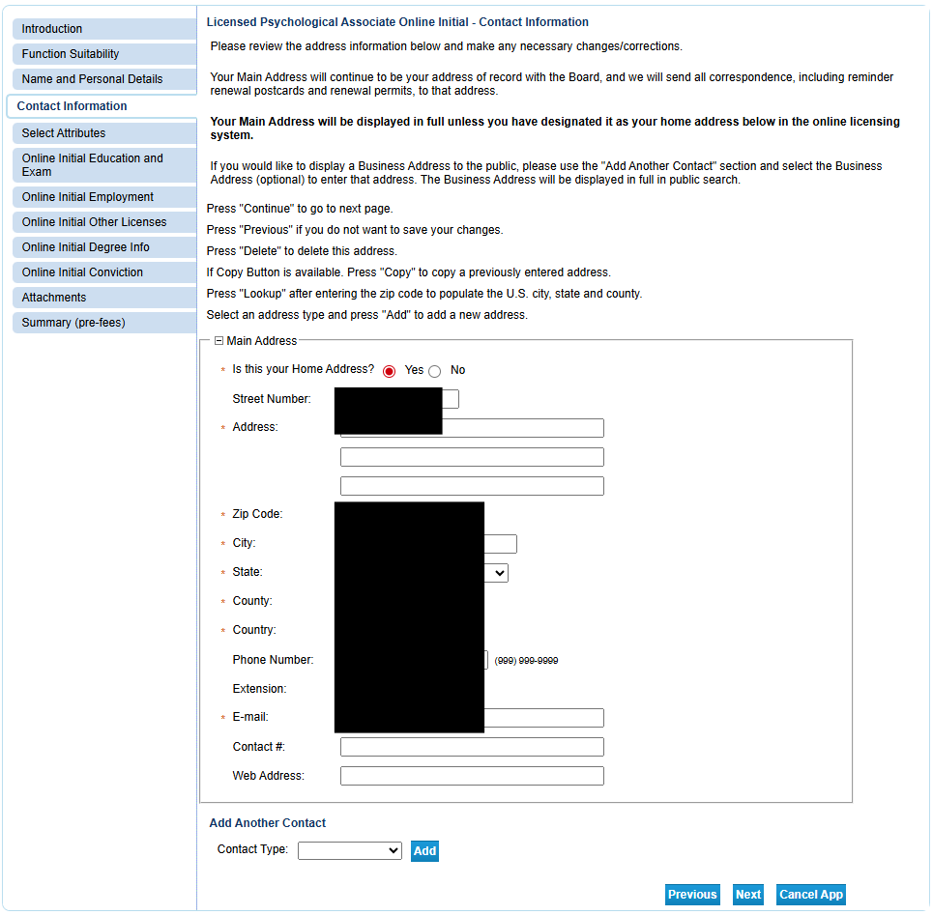

Step 7 – Military Status
- Select your military status (if applicable). This affects aspects of the process, so answer accurately.
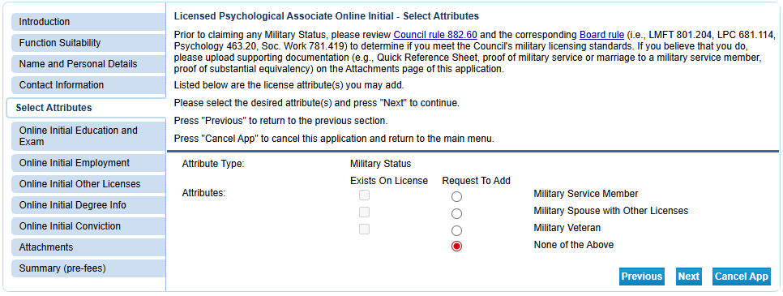
Step 8–12 – Education, Citizenship, and License History
- Provide your education details.
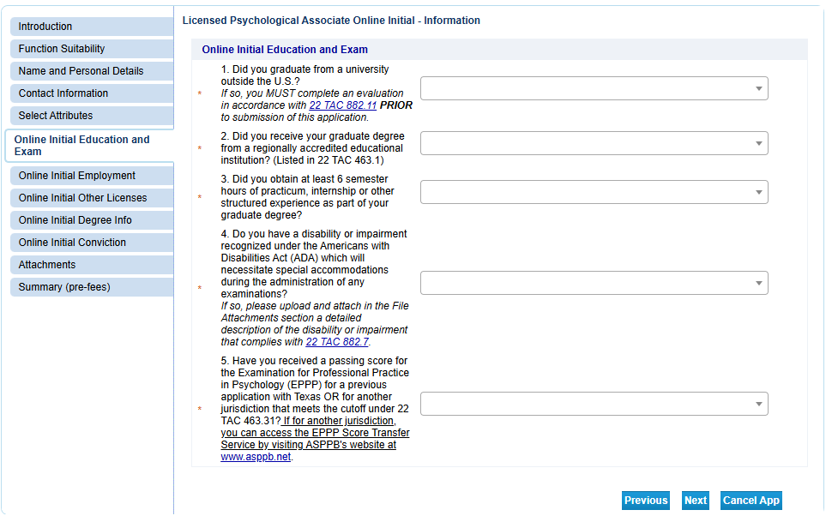
- Enter your citizenship and employment status.
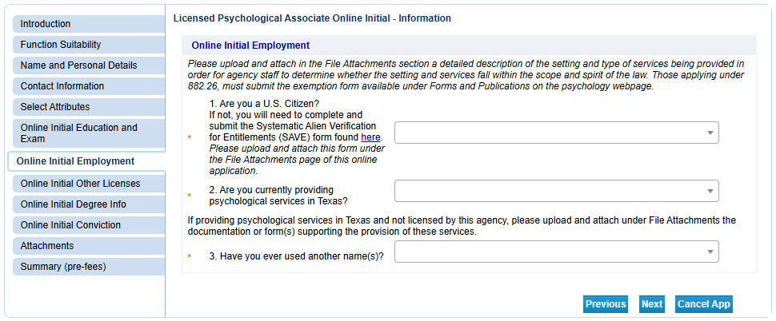
- Answer questions about past professional licenses (if any).
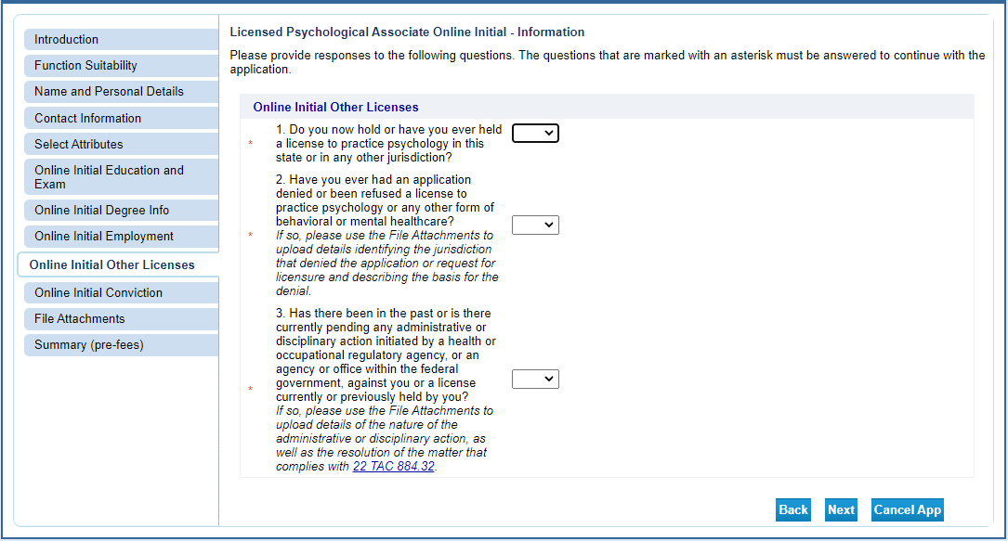
- Answer competence-related questions.

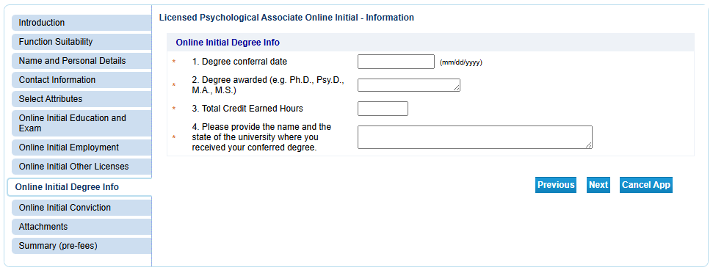
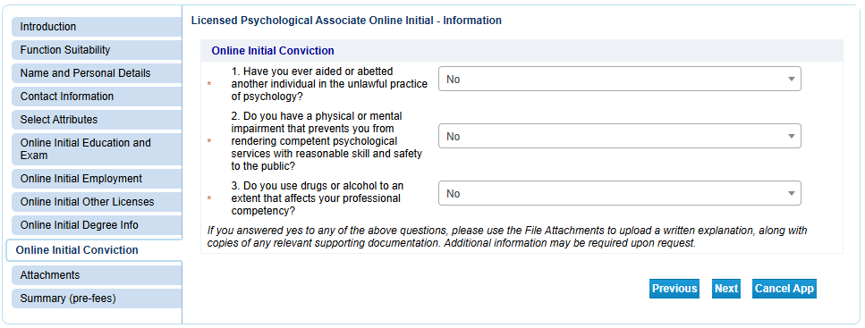
Step 13 – Upload Supplemental Documents
- Upload documents such as your jurisprudence exam certificate.
- Click Choose File, select the file, and click Open.
- Add a brief description in the Notes section, then click Attach.
- Repeat as needed for additional files.
- Ensure total size does not exceed 20MB.
- You may view or remove files before continuing.
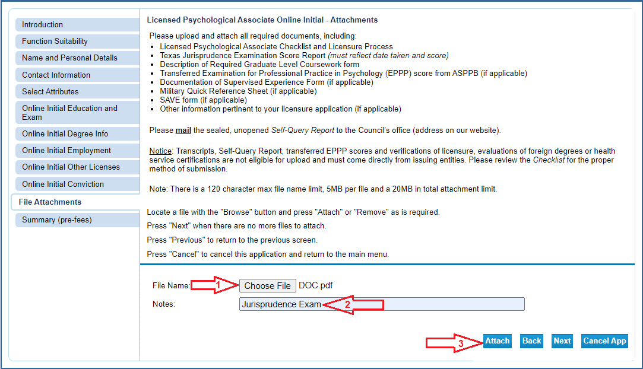
Step 14 – Review Application
- Review all information for accuracy.
- Click Submit to save and move to the affirmation page.
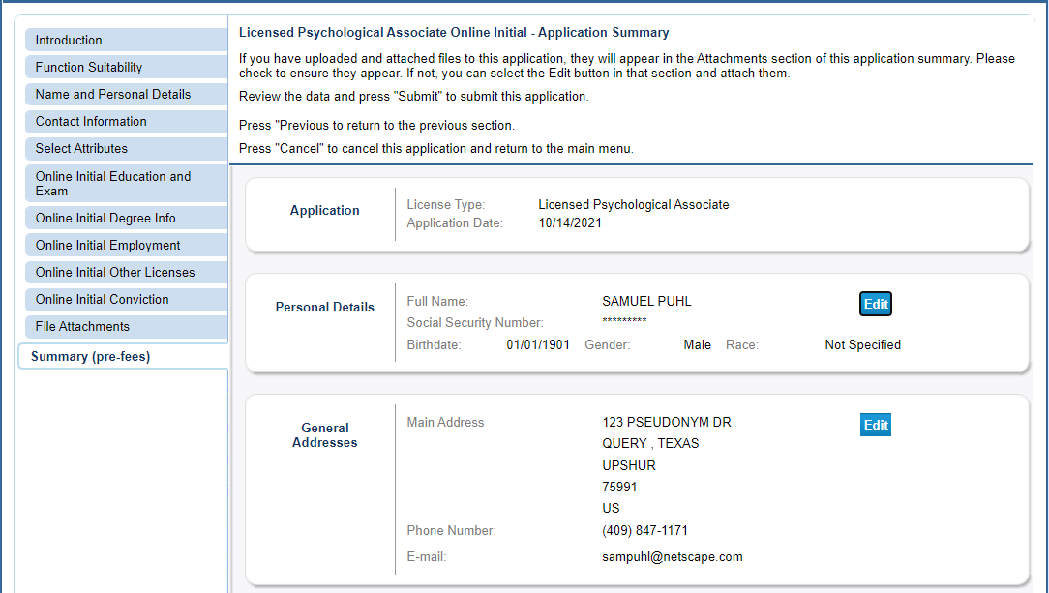


Step 15 – Affirmation
- Select Yes to agree to the affirmation and click Next.
- You will receive a confirmation email with a PDF summary and fingerprinting instructions.
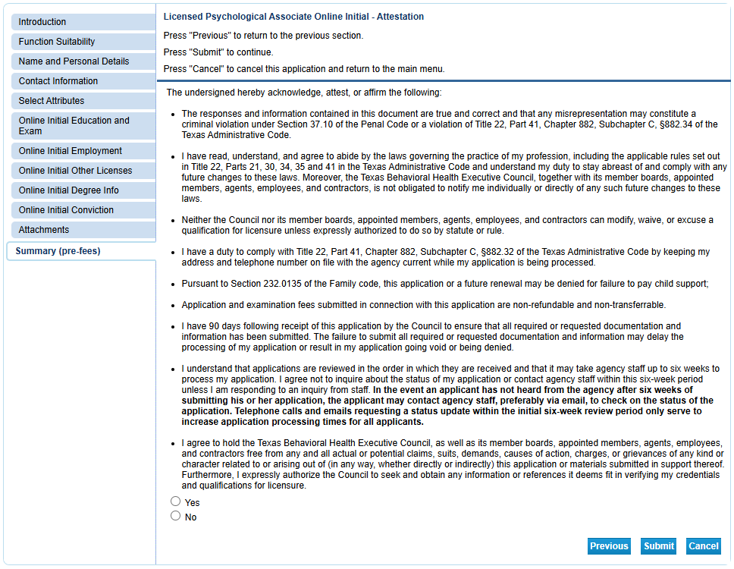
Step 16–23 – Payment
- Click Pay Now to begin payment.
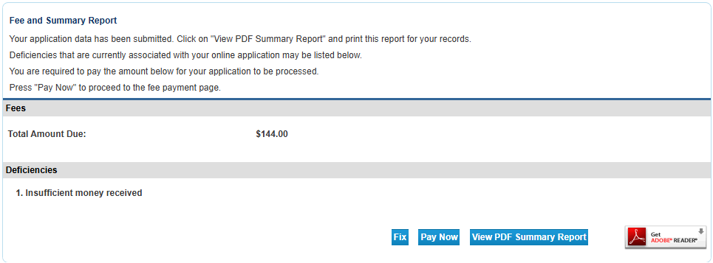
- If you selected a military option, Texas law exempts you from fees and you will skip payment.
- Select the “Licensed Psychological Associate Online Initial” checkbox and then “Next”
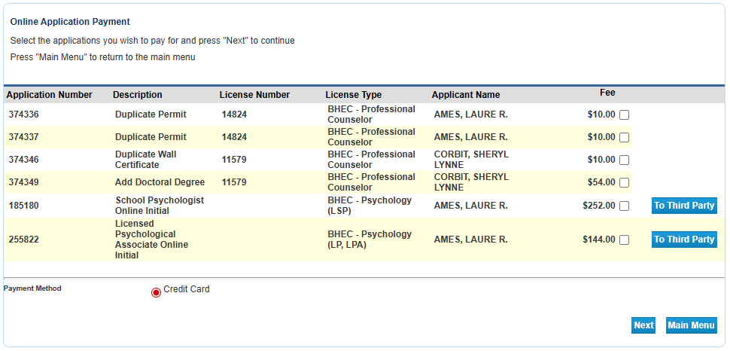
- Otherwise:
  - Enter customer information.
  - Enter credit card details.
  - Complete CAPTCHA verification.
  - Submit payment.
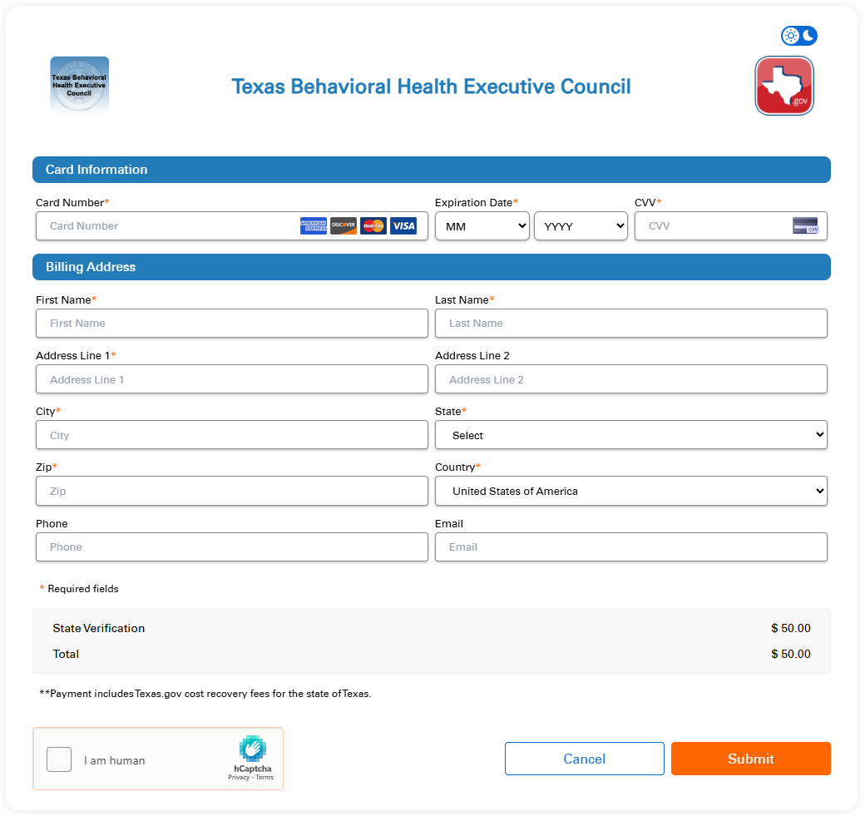
- After payment, you will be redirected to a success page and receive an email confirmation. Save both for your records.
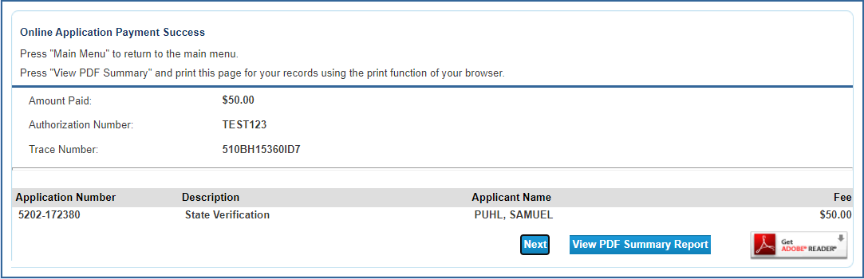

After Submission
- Your application will be reviewed in the order received.
- Staff may contact you if additional documentation is needed.
- If complete, your license will be issued.
- Due to high volume, please allow at least six weeks before contacting BHEC for a status update.

